Stone Barn Community Farm

Community Supported Agriculture at work in New Hampshire

Established as a community farm in 2001, Stone Barn Farm is a USDA Certified Organic producer of vegetables, fruits, and flowers located in the scenic Contoocook Valley of southwestern New Hampshire. Our Community Supported Agriculture (CSA) program is entering its tenth season. 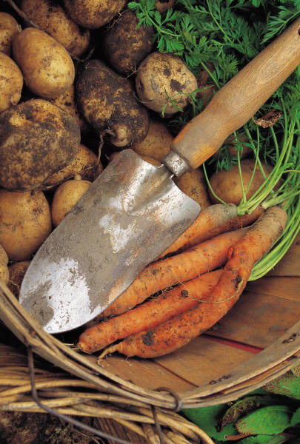

What is Community Supported Agriculture?

Community Supported Agriculture (CSA) is a partnership between farmers and the people who use the farmer's produce. Within this partnership is the idea that all people are responsible for the care of the earth. Members of a CSA support the farmers as they tend the earth in a responsible way while growing the highest quality produce. For members, being in a CSA is like having your own personal farmer. In a CSA, you become a member of a local farm by purchasing a “share” in that farm. In return, you receive a weekly share of the harvested produce throughout the growing season. This economic arrangement benefits farmers because we have improved cash flow in the beginning of the year and guarantees a market for our products. This arrangement benefits members because you receive fresh, locally grown produce. This arrangement benefits the entire community by keeping local farms and jobs viable and securing a healthy food supply. 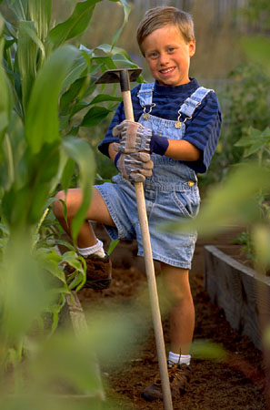

How does it work?

We, the farmers, are responsible for the planting, tending, and harvesting of the crops. Farm members buy a share of our harvest in advance of the growing season, and then each week during the growing season members pick up their harvested produce at the farm. The share price for 2010 at Stone Barn Community Farm is $350. From mid- June until October 1, you can expect a variety of fresh, in-season vegetables in the harvest. The earliest harvests are limited to leafy greens, salad makings, and some herbs. Mid-summer harvests bulge with veggies in large variety and quantity. Most seasons there are some crops that do exceptionally well and others that produce less than expected. As partners in agriculture we share the benefits of bumper crops and the risks of a crop failure. Farm pick-up is Mondays and Thursdays from 5 p.m. to 7 p.m.

What does Stone Barn Community Farm do?

We grow over 250 varieties of fruits and vegetables using organic methods. We also sell our produce at our farm stand and at local farmers’ markets.

Stone Barn Community Farm

P.O. Box 78

Greenfield, NH 03047

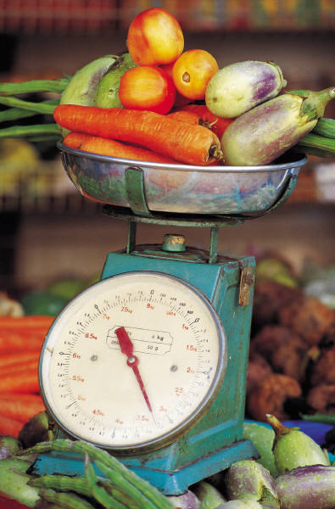

Do you know where your food comes from?

Do you want to eat fresh, locally grown, organic food?

Do you want to support local farms and provide jobs?

Become a member of Stone Barn Community Farm.

For more information on Stone Barn Community Farm

and Community Supported Agriculture,

call 555-3948 or visit stonebarncsa.org.